Ana-Maria Nanes

Assignemnt 1

* **How to install your application on a clean computer:**

The followig tools must be installed:

* Eclipse
* MySql

Firstly, the scrispt for creating the database in executed in order to create the database called csdepartment.

Secondly, the SQL code for inserting data into the database is executed.

Then the project is imported in Eclipse.

The jar called mysql-connector-java-5.1.9.jar should be downloaded and added to the path of the project in Eclipse.

In the file ConnectionFactory.java the strings USER and PASSWORD must be set according to the ones used in MySql on the computer.

* **How to access your application and with what users:**

After the previous steps have been followed, the project can be run in Eclipse.

The users are the students and the teachers at the Computer Science Department at TUCN. In order to have access to the application they must log in if they have an account, or they can create an account.

Both the log in, and the registration operations can be done from the home page that is visible to all users and which is the same for all users.

After a teacher logs in, the user interface for teachers allows him/her to perform the necessary operations.

After a student logs in, the user interface for students allows him/her to perform the necessary operations.

* **Images with all use cases and their scenarios implemented**

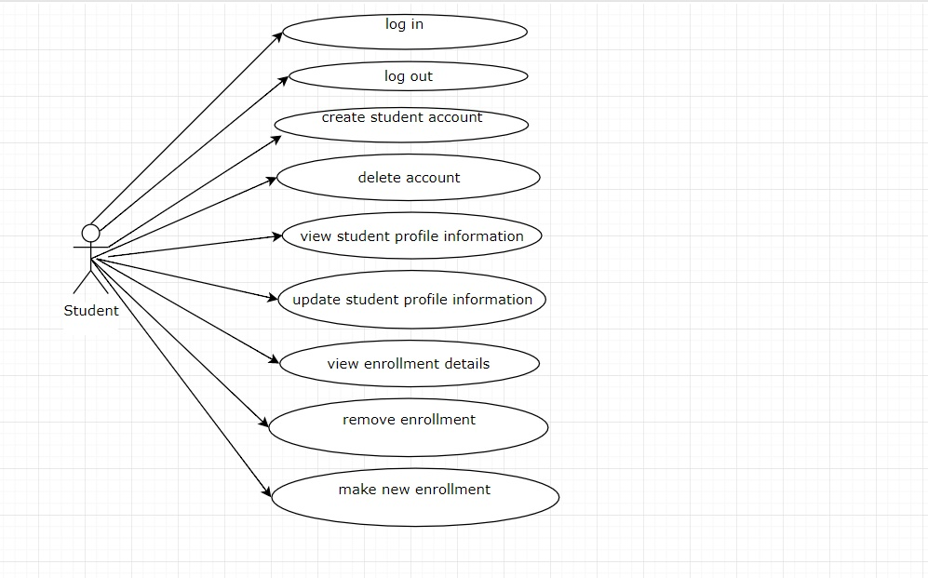The use case diagram: (for student and teacher)

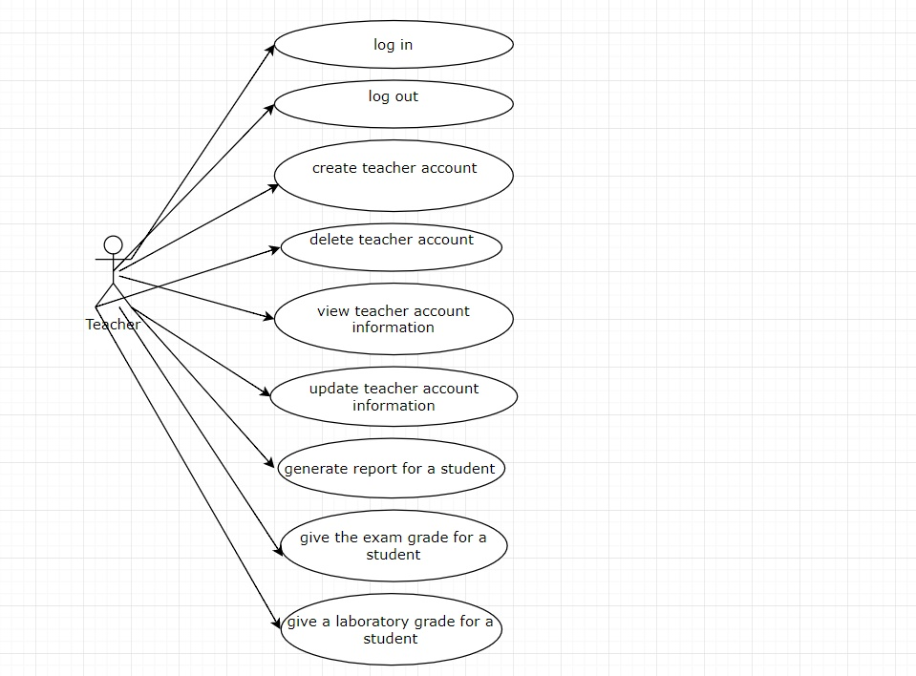

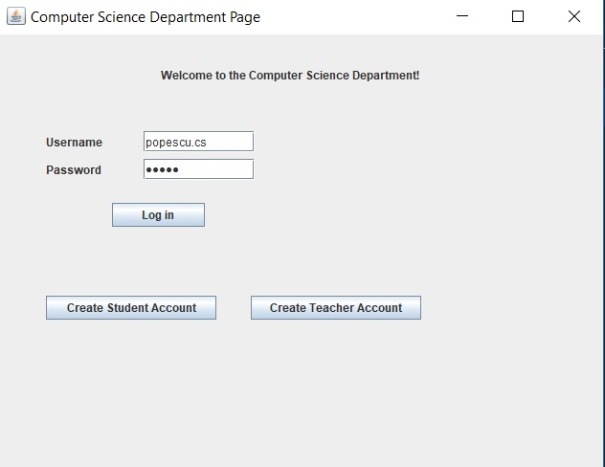Home page:

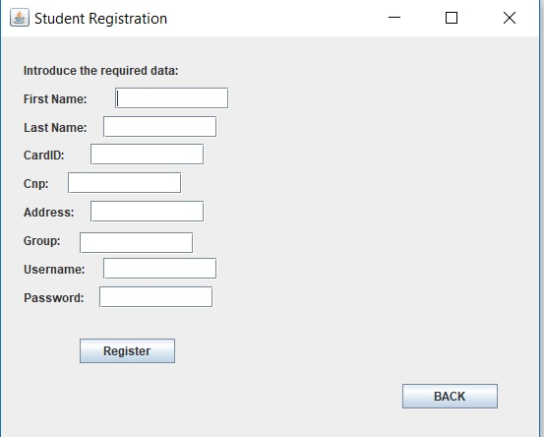

Student Registration:

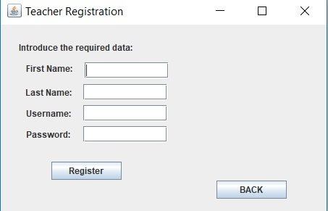

Teacher Registration:

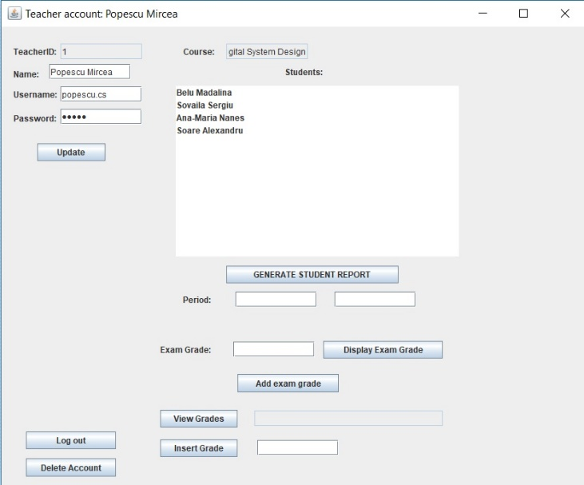

Teacher Account:

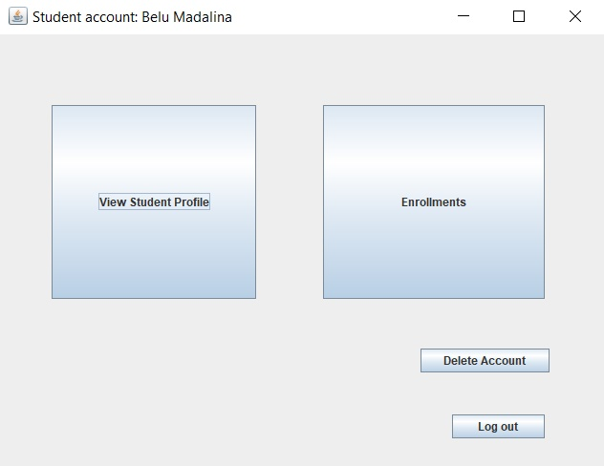

Student Account:

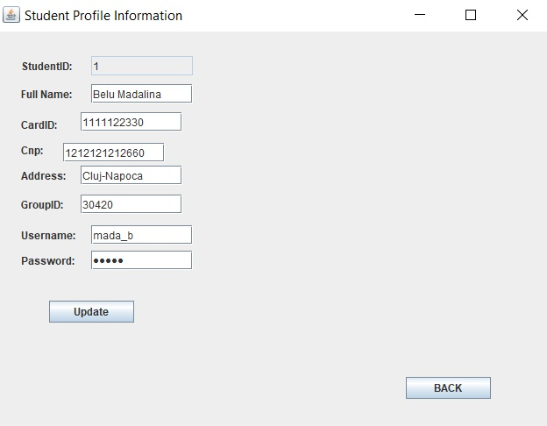

Student Account Info:

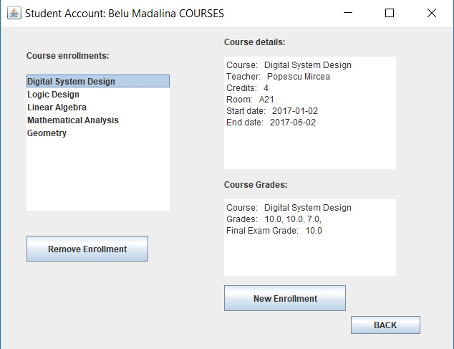

Student Enrollments:

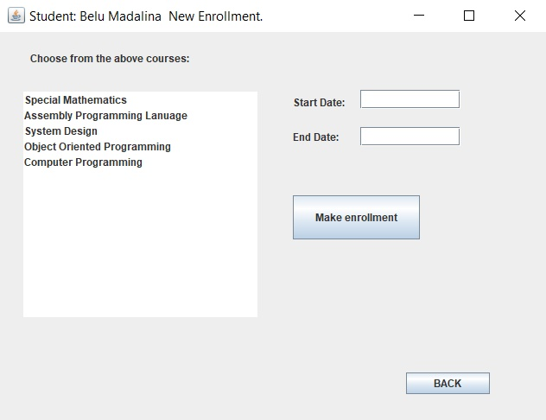

New Enrollments: